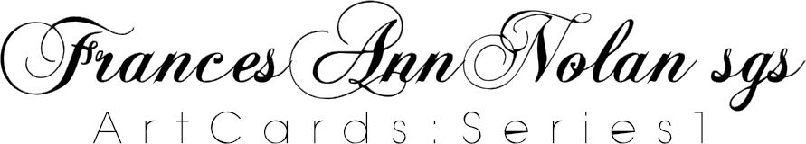
ORDER FORM

ORDERED BY DATE: Use calendar to select date.
Title – please select |  |  | First Name |  |  | Surname
ADDRESS
Address
SUBURB  Suburb |  |  |  |  | POSTCODE  Postcode
STATE  State |  |  |  |  | COUNTRY  Country
EMAIL
Email
GST STATUS | (Member of Australian Catholic Church Religious Group) YES ☐ |  |  | ABN | Enter ABN
MAILING TO – Please complete if different from above
NAME |  | Title – please select | First Name |  |  | Surname
ADDRESS |  | Address
SUBURB |  | Suburb |  |  | POSTCODE | Postcode
STATE |  | State |  |  | COUNTRY | Country

NOTE: To update totals – in the TOTAL AMOUNT column right click in the appropriate cell and click ‘update field’
ITEM | DESCRIPTION | UNIT PRICE | QUANTITY | TOTAL AMOUNT
Pack Set | Set 12 different designs | $32.00 |  | $ 0.00
Individual Cards  Card size:  145mm x 145mm  (indicate individual card preference) | Design No 1 | $4.50 |  | $ 0.00
 | Design No 2 | $4.50 |  | $ 0.00
 | Design No 3 | $4.50 |  | $ 0.00
 | Design No 4 | $4.50 |  | $ 0.00
 | Design No 5 | $4.50 |  | $ 0.00
 | Design No 6 | $4.50 |  | $ 0.00
 | Design No 7 | $4.50 |  | $ 0.00
 | Design No 8 | $4.50 |  | $ 0.00
 | Design No 9 | $4.50 |  | $ 0.00
 | Design No 10 | $4.50 |  | $ 0.00
 | Design No 11 | $4.50 |  | $ 0.00
 | Design No 12 | $4.50 |  | $ 0.00
TOTALS |  |  |  | $ 0.00
Please indicate if you require a receipt of payment YES☐ NO☐
On receipt of your order a tax invoice will then be sent to your email/postal address. This will indicate postage cost, handling and GST (if applicable). Payment is to be sent on receipt of Tax Invoice.
INSTRUCTIONS to Return Order Form:
By email (go to ‘File’ – ‘Save & Send’ – ‘Send using email’) to artcards@goodsams.org.au OR print and post to Art Cards PO Box 1076 GLEBE NSW 2037

